# COMMUNITY SERVICE PROJECT AT

### ASHIANA OLD AGE HOME TRUST

Internship project report submitted in partial fulfilment for the award of degree of

**BACHELOR OF COMMERCE**

of

## **BENGALURU CITY UNIVERSITY**

Submitted by

### ANUSHA R

STUDENT ID NO.20027619 REGISTERNO.CNO.C20611

### **Under the guidance of**

**DIVYA SHREE.B.R**

ASSISTANT PROFESSOR

DEPARTMENT OF COMMERCE AND MANAGEMENT



## **NAGARJUNA DEGREE COLLEGE**

(Affiliated to Bengaluru City University)

**# 38/36, Ramagondanahalli, Yelahanka, Bengaluru -560 064.**

**Phone: 6364231112**

**E Mail:** [**nccms2013@gmail.com**](mailto:nccms2013@gmail.com) **Website:** [**www.nagarjunadegreecollege.co.in**](http://www.nagarjunadegreecollege.co.in/)

**COMMUNITY SERVICE**

**INTRODUCTION**

Community service is unpaid work performed by a person or group of people for the benefit and betterment of their community without any form of compensation, Community service can be distinct from volunteering, since it is not always performed on a voluntary basis and may be compulsory. Although personal benefits may be realized, it may be performed for a variety of reasons including citizenship requirements, a substitution of criminal justice sanctions, requirements of a school or class, and requisites for the receipt of certain benefits.  
  
**DEFINITION**  
  
According to Fayetteville State University, "service leaming is a process of involving students in community service activities combined with facilitated means for applying the experience to their academic and personal development. It is a form of experiential education aimed at enhancing and enriching student learning in course material. When compared to other forms of experiential leaming like internships and cooperative education, it is similar in that it is student-cantered, hands-on and directly applicable to the curriculum."  
  
**BACKGROUND**  
  
Community service is a non-paying job performed by one person or a group of people for the benefit of their community or its institutions. Community service is distinct from volunteering, since it is not always performed on a voluntary basis. It may be performed for a variety of reasons.

* It may be required by a government as a part of citizenship requirements, like the mandatory "Hand and hitch-up services" for some municipalities in Germany, or generally in lieu of military service or for civil conscription services.
* It may be required as a substitution of, or in addition to, other criminal justice sanctions - when performed for this reason it may also be referred to as community payback.
* It may be mandated by schools to meet the requirements of a class, such as in the case of service-learning or to meet the requirements of graduating as class valedictorian.
* In the UK, it has been made a condition of the receipt of certain benefits. (See Workfare in the United Kingdom).
* In Sweden it is a suspended sentence called

"samhällstjänst” ("society service").

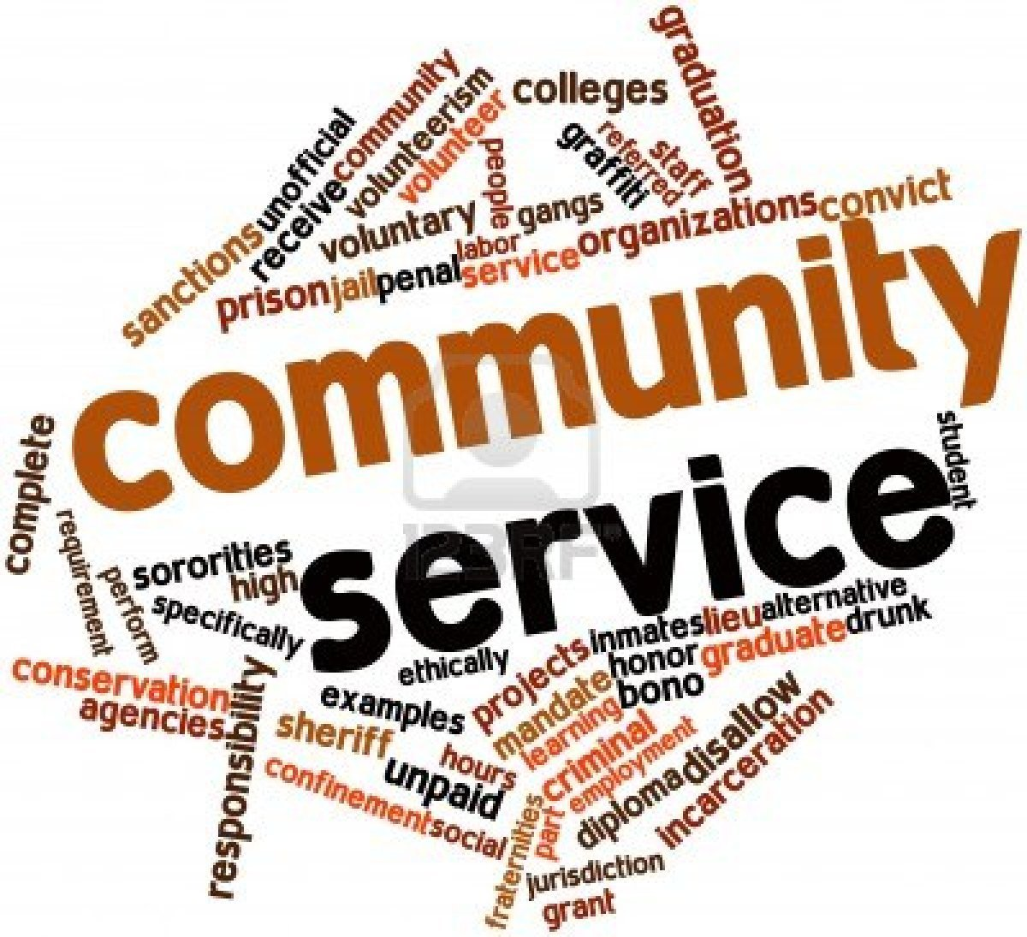

**COLLEGES**  
  
Though not technically considered a requirement, many colleges include community service as an unofficial requirement for acceptance. However, some colleges prefer work experience over community service, and some require that their students also continue community service for some specific number of hours to graduate. Some schools also offer unique "community service" courses, awarding credit to students who complete a certain number of community service hours. Some academic honour societies, along with some fraternities and sororities in North America, require community service to join and others require each member to continue doing community service.

Many students’ organizations exist for the purpose of community service, the largest of which is Alpha Phi Omega. Community service projects are also done by sororities and fraternities.  
  
Beginning in the 1980s, colleges began using service-leaming as a pedagogy. A partnership of college presidents began in 1985 with the initiative of boosting community service in their colleges. This alliance called Campus Compact,[5] led the way for many other schools to adopt service-learning courses and activities.  
  
Service-learning courses vary widely in time span, quality, and in the balance of "service" and "learning" stressed in the course. A typical service learning course, however, has these factors in common:

* A service component where the student spends time serving in the community meeting actual needs.
* A learning component where students seek out or are taught information-often both interpersonal and academic-that they integrate into their service.
* A reflection component that ties service and learning together.

**COMMUNITY SERVICE-LEARNING**  
  
The one serving may be able to take something away from the experience and be able to use any newfound knowledge or interpersonal discoveries to improve their future servitude and the people around them. To gain the most from community service requires balancing learning with serving. Learning and serving at the same time improves a student's community while teaching life lessons and building character.  
  
Community service-learning is "about leadership development as well as traditional information and skill acquisition". Therefore, the combination of people doing service and learning at the same time teaches them how to be effective and how to be effective regarding what is important to them. It can improve their overall experience and application opportunities they gain from it. By adding service to leaming, and balancing the two, community service can become more than just the act of serving. The goal of service-learning is to achieve large change through small actions. By being a classroom, a hands-on learning experience, and an opportunity to change the community, people are able to not only serve, but impact themselves as well.

**NON-GOVERNMENT ORGANIZATION (NGO)**

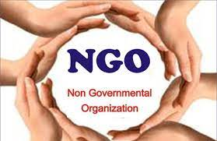

**Introduction:**

NON-GOVERNMENT ORGANIZATION (NGO) is an organization that generally is formed independent from Government. They are typically nonprofit entities, and many of them are Achieve in Humanitarianism or the Social Science; they can also include clubs and associations that provides services to their members and others. Surveys indicate that NGO’s have a high degree of public trust, which can wake them a useful proxy for the concerns of society and stakeholders. However, NGO’s can be also lobby groups for corporations, Such as the world Economic forum.

The term as it is used today was first introduced in Article 71 of the newly formed united National Charter in 1945.While there is no fixed or formal definition for what NOG’s are, they are generally defined as nonprofit entities that are independent of government influence – although they may receive government funding. According to the UN Department of Global Communications, an NGO is “a not-for-profit, voluntary citizen’s group that is organized on a local, national or international level to address issues in support of the public good. “The term NGO is used inconsistently and is sometimes used synonymously with civil society organization (CSO), with is any association founded by citizens. In some countries, NGOs are known as nonprofit organizations, and political parties and trade unions are sometimes considered NGO’s as well.

NGOs are classified by (1) orientation-the type of activities an NGO undertakes, such as activities involving human rights, consumer protection, environmentalism, health, or development; and (2) level of operation, which indicates the scale at which an organization works: local, reginal, national, or international.

Russia had about 277,000 NGOs in 2008. India is estimated to have had about 2 million NHOs in 2009 (approximately one per 600 Indians), many more than the number of the country’s primary schools and health centers.

**WORLD NGO DAY**

World NGO Day, observed annually on 27 February, was recognized on 17 April 2010 by 12 countries of the IX Baltic Sea NGO Forum at the eight Summit of the IX Baltic Sea States in Vilnius, Lithuania. It was internationally recognized on 28 February 2014 in Helsinki, Finland by United Nations Development Programme administrator and former Prime Minister of New Zealand Helen Clark.

**HISTORY**

International non-governmental Organization date back to at least the late 18th century, and there were an estimated 1,083 NGOs by 1914. International NGOs were important to the anti-slavery and women’s suffrage movements, and peaked at the time of the 1932 -1934 World Disarmament Conference.

The term became popular with the 1945 founding of the unites Nations in 1945; Article 71 in Chapter X of its charter stipulated consultative status for organizations which are neither governments nor member states. An international NGO was first defined in resolution 288 (X) of the United Nations.

Economic and Social Council (ECOSOC) on February 27, 1950, as “any international organization that is not founded by an international treaty”. The role of NGOs and other “Major groups” in sustainable development was recognized in Chapter 27 of Agenda 21. The rise and fall of international NGOs matched contemporary events, waxing in periods of growth and waning in times of crisis. The United Nations gave non-governmental organizations observer status at its assemblies and some meetings. According to the UN, an NGO is a private, not-for-profit organization which is independent of government control and is not merely an opposition political party.

**LEGAL STATUS**

Although NGOs are subject to national laws and practices, four main groups may be found worldwide:

* Unincorporated and voluntary association
* Trust, charities and foundations
* Not-for-profit companies and co-operatives
* Entities formed (or registered) under special NGO or nonprofit laws.

**TYPES**

NGOs further the social goals of their members (or founders): improving the natural environment, encouraging the observance of human rights, improving the welfare of the disadvantaged, or representing a corporate agenda. Their goals cover a wide range of issues. They may fund local NGOs, institutions and projects, and implement projects.

NGOs are classified by their:

1. Orientation, i.e., the type of activities an NGO undertakes, such as activities involving human rights, consumer protection, environmentalism, health, or development.
2. Level of operation, which indicated the scale at which an organization works: local, regional, national, or international.



**ORIENTATION**

* Charity – often a top-down effort, with little participation or input from beneficiaries, They include NGOs directed at meeting the needs of disadvantaged people and groups.
* Service – includes NGOs that provide healthcare (including family planning) and education.
* Participatory – self-help projects with local involvement in the form of money, tools, land, materials, or labour.
* Empowerment – aim to help poor to understand the social, political, and economic factor affecting their lives, and to increase awareness of their power to control their lives. With maximum involvement by the beneficiaries, the NGOs are facilitators.

**LEVEL OF OPERATION**

* Community-based organizations (CBOs) – popular initiatives which can raise the consciousness of the urban poor, helping them understand their right to services, and providing such services.
* City-wide organizations – include chambers of commerce and industry, coalitions of business, ethnic or educational groups, and community organizations.
* State NGOs – include state-level organizations, associations, and groups. Same state NGOs are guided by national and international NGOs.
* National NGOs – and NGO that exists in only one country: they are rare. These include national organizations such as YMCAs, professional associations, and similar groups. Some have state or city branches and assist local NGOs.
* International NGOs (INGOs) – range from secular agencies, such as Save the Children, to religious groups. They may fund local NGOs, institutions and projects, and implement projects.

**Ashiana Home**

**INTRODUCTION**

Al Aman Educational & Welfare Trust was registered under the Indian Trust act on 19th Feb 1997 with objective of serving the people in need without any discrimination in the name of caste, class or creed. The Trust was formed by a group of individuals who were committed to render relentless service towards the development of the underprivileged. The trust is working for women and child welfare and bringing about a change in their lifestyle. Our Programs are based on education, healthcare, women empowerment, child care which are focused on abandoned women, physically/visually challenged children and senior citizen. Thus the Trust has concentrated on Healthcare Environmental awareness, Self-employment, leadership training for women, and other such socio-economic activity live Old Age Home, Rural women education, Child care etc. In addition to the above we are focusing on ecological development and national integration.

#### Philosophy

The basic philosophy of our organization is to work voluntarily for the overall development of socially and economically disadvantaged people, senior citizens, women and children.

#### Mission

To devote all our efforts, resources and manpower to ensure accepted standards in education and health by creating favorable social and cultural environment.

#### Vision

Underprivileged people achieve the desired changes in their lives and livelihood.

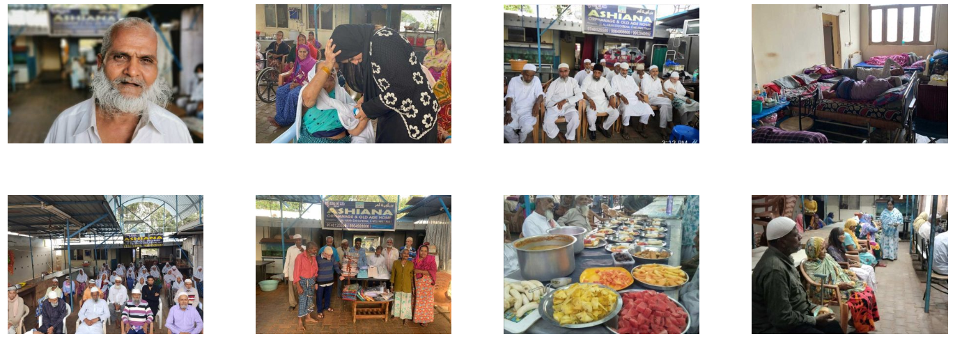

# Ashiana Old Age Home

# Ashiana blind and visually Residential School

**Ashiana Charitable Clinic**

**Ashiana Food Bank**

**Ashiana Scholarship**

SERVICES

# Ashiana Old Age Home

Ashiana old age home was started in 2010 it is located at # 82 Kannamangala Palya, Kannamangala post, Devanahalli Taluk, Bangalore rural. We started off with 1 destitute elder who was in need of a home to stay. Here we admit destitute elders who do not have close kith or kin to care for them. It is a charitable old age home with all modern facilities where the elders are not burdened with any work or worries. We provide them with fresh food, medicines and other daily needs. We care for them till their last breath. Over 200 residents have passed away peacefully in Ashiana old age home. We have appointed staff members to care for their necessities and we treat our residents with utmost love and respect. It is a realm for the troubled elders in their twilight years we do not differentiate them on any basis.

**Adopt a Parent**

|  |  |
| --- | --- |
| **Adopt a Parent** | **Rs 6000/-** |

**Monthly expenses**

|  |  |
| --- | --- |
| **Groceries** | **Rs 50,000/-** |
| **Medicines and medical expenses** | **Rs 30,000 to 40,000/-** |
| **Expenses average** | **Rs 30,000 to 40,000/-** |
| **Salaries** | **Rs 90,000/-** |
| **Electricity between** | **Rs 12,000 to 15,000/-** |
| **Milk** | **Rs 7500/-** |
| **Miscellaneous** | **Rs 5000/-** |

**Special Donations**

|  |  |
| --- | --- |
| **Breakfast** | **Rs 2,000/-** |
| **Lunch** | **Rs 2,500/-** |
| **Veg Biryani** | **Rs 3000/-** |
| **Chicken Biryani** | **Rs 5000/-** |
| **Mutton Biryani** | **Rs 8000/-** |
| **Dinner and Veg** | **Rs 3000/-** |
| **Milk and Evening snacks** | **Rs 1000/-** |

**Ashiana Residential School for the Blind, Dumb and Deaf,  
Physically Challenged and Orphan Children**

Three floors are dedicated for the underprivileged, differently abled and orphan children of the society these two floors are still under construction. We have completed the moulding of these floors however we are in short of fund for the completion and furnishing of these floors.

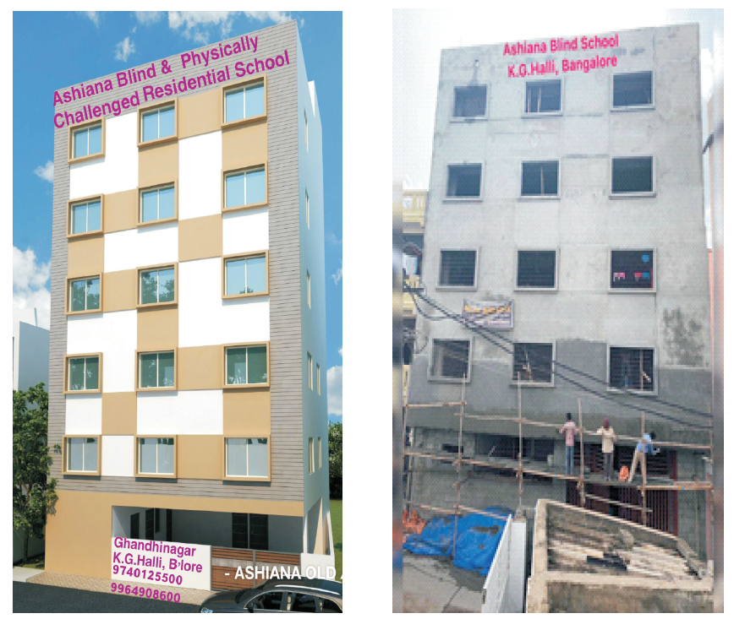

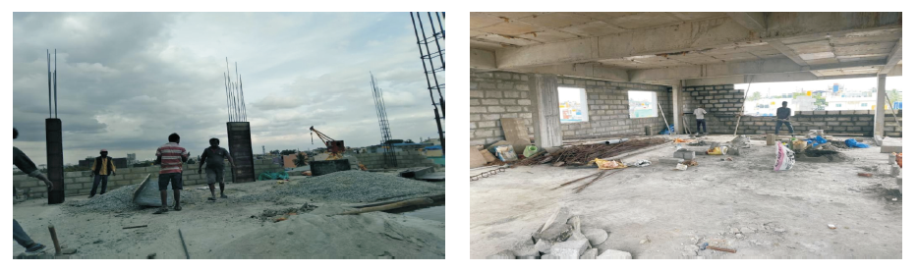

# Required Funds for the Construction

|  |  |
| --- | --- |
| **Plastering labour** | **Rs.3,00,000 /-** |
| **Outer plastering labour** | **Rs.2,25,000/-** |
| **Construction of walls** | **Rs.80,000/-** |
| **Wiring and fitting** | **Rs.1,50,000/-** |
| **Painting** | **Rs.1,00,000/-** |
| **Tiles and fitting** | **Rs.2, 25,000/-** |
| **Aluminium windows** | **Rs.1,05,000/-** |
| **Doors** | **Rs.90,000/-** |
| **Sanitary work** | **Rs.,73,000/-** |

# Lift Expenses

|  |  |
| --- | --- |
| Lift Expenses | 13,77,745/- |

# Furnishing

|  |  |
| --- | --- |
| Bunker beds | Rs.2,00,000/- |
| Cupboards | Rs.50,000/- |
| Washing machine | Rs.12,000/- |
| Bed sheet, bed cot, pillows, blanket | Rs.60,000/- |

# Overall maintenance of the building

|  |  |
| --- | --- |
| **Electricity** | **Rs.15,000/-** |
| **Maintenance** | **Rs.8,000/-** |

**Ashiana Charitable Clinic**

Ashiana charitable clinic is located in K G Halli. Here general tests and medicines are free of cost for the poor and needy

[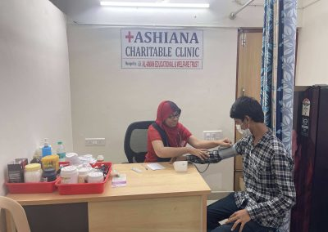](https://ashianahome.org/wp-content/uploads/2021/11/IMG_6929-scaled.jpg) [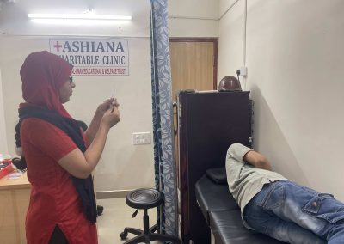](https://ashianahome.org/wp-content/uploads/2021/11/IMG_6932-scaled.jpg)

[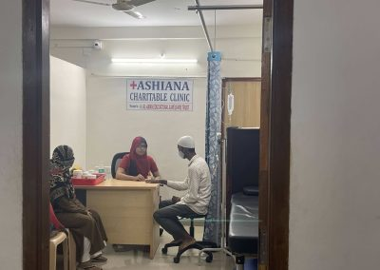](https://ashianahome.org/wp-content/uploads/2021/11/IMG_6941-scaled.jpg) [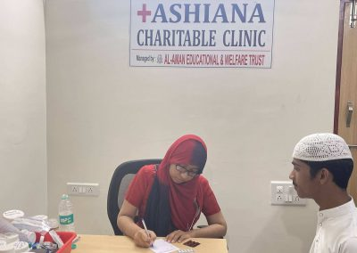](https://ashianahome.org/wp-content/uploads/2021/11/IMG_6938-scaled.jpg)

[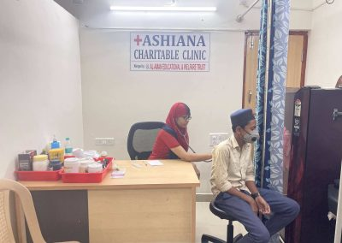](https://ashianahome.org/wp-content/uploads/2021/11/IMG_6927-scaled.jpg) [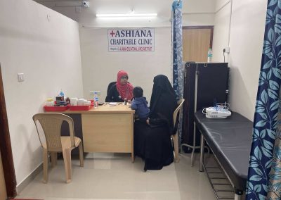](https://ashianahome.org/wp-content/uploads/2021/11/IMG_6278-scaled.jpg)

[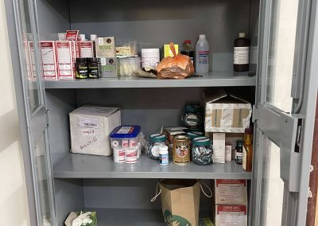](https://ashianahome.org/wp-content/uploads/2021/11/IMG_6268-scaled.jpg) 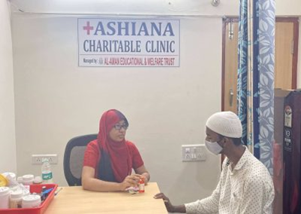

MONTHLY EXPENESES

|  |  |
| --- | --- |
| DOCTORS SALARY | RS.20,000/- |
| ASSISTANTS NURSES SALARY | RS.8,000/- |
| MEDICINE | RS.20,000 TO 25,000/- |

**Ashiana Food Bank**

At Ashiana food bank we cater fresh food to the dialysis and cancer patient on daily basis there are numerous patients who are extremely poor and cannot afford fresh meals we cater food to about 200 patients and 200 poor people on a daily basis we prepare fresh food, packet for individuals and deliver it to hospitals everyday. We even distribute food to the poor children, in slums & at our food bank counter.

[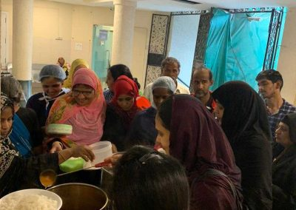](https://ashianahome.org/wp-content/uploads/2021/11/1a243301-1b74-4942-a328-2b39f45427d2-1.jpg) [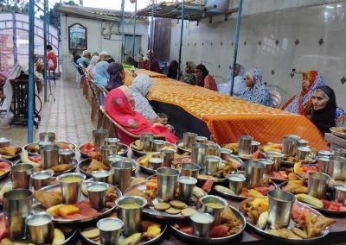](https://ashianahome.org/wp-content/uploads/2021/11/1f20a0f4-5de2-4234-8fe0-9cab811b4cdd-1.jpg)

[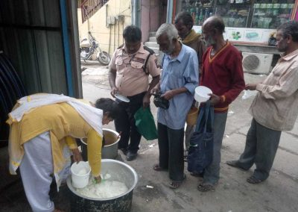](https://ashianahome.org/wp-content/uploads/2021/11/3b249fcf-3207-4781-8d3f-6abfa65feb2e-1.jpg) [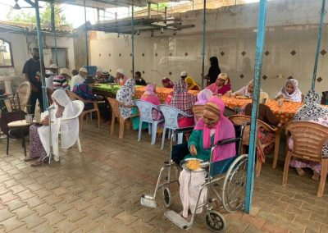](https://ashianahome.org/wp-content/uploads/2021/11/5bcfd9a6-819d-4a66-8e43-9ac45b894bda-1.jpg)

[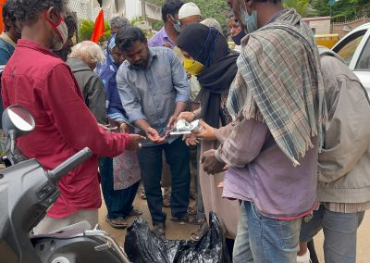](https://ashianahome.org/wp-content/uploads/2021/11/IMG_2497-scaled.jpg) [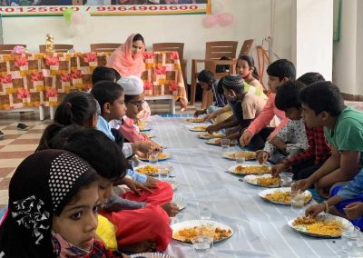](https://ashianahome.org/wp-content/uploads/2021/11/566b6e6d-9c85-4152-bd4e-fb5182e8756d-1.jpg)

[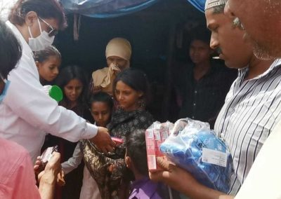](https://ashianahome.org/wp-content/uploads/2021/11/2513e46e-9daa-41ae-9952-059d359509f2-1.jpg) [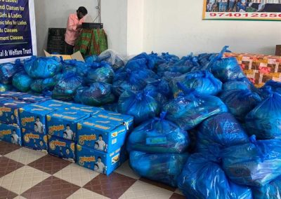](https://ashianahome.org/wp-content/uploads/2021/11/a710672c-550c-4122-961f-e122ea4b50f1-1.jpg)

Monthly Expenses

|  |  |
| --- | --- |
| Groceries | Rs.60,000/- |
| Cooking gas & Miscellaneous | Rs.15,000/- |
| Salaries | Rs.20,000/- |
| Transportation | Rs.6,000/- |

# Ashiana Skill Development Institute

The classrooms are on the first floor where we provide free courses especially for the empowerment of ladies and girls.

**The courses provided are as follows:**

* Fashion Designing, Tailoring
* Computer course for visually impaired & hearing impaired.
* Computer course (basic, tally, hardware, web designing)
* Spoken English
* Spoken Kannada
* Self-grooming
* Personality development
* Henna design application

[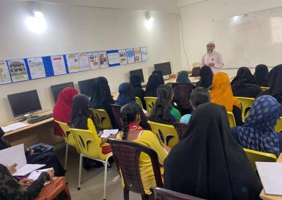](https://ashianahome.org/wp-content/uploads/2021/11/5bead956-c379-439e-8fe5-04ac1a8e1394.jpg) [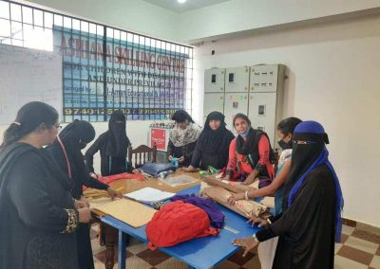](https://ashianahome.org/wp-content/uploads/2021/11/b0685e53-e983-4ad9-aa82-0a0c2f84dc04.jpg)

[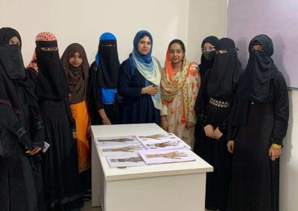](https://ashianahome.org/wp-content/uploads/2021/11/996f0e03-4973-4196-a027-cf9817342116.jpg) [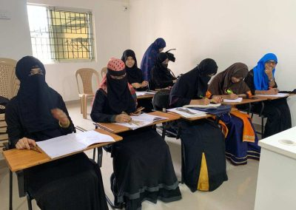](https://ashianahome.org/wp-content/uploads/2021/11/7e8c2cda-5922-422d-92fc-8cb4a4a270e0.jpg)

[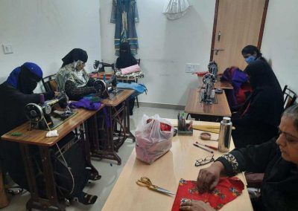](https://ashianahome.org/wp-content/uploads/2021/11/adf28f96-47b4-42c8-87a1-bc3304473fc3.jpg) [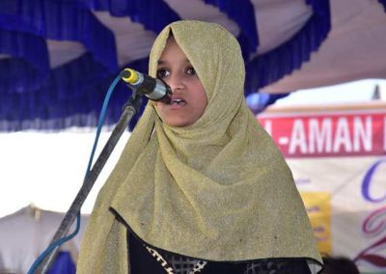](https://ashianahome.org/wp-content/uploads/2021/11/6c3b8957-b143-409f-903c-f2e49db5f2fc.jpg)

# Monthly Expenses

|  |  |
| --- | --- |
| Salaries | Rs.1,05,000/- |
| Maintenance & Material | Rs.30,000/- |
| Electricity | Rs.8,000 to 10,000/- |

# Ashiana Scholarship

They do a survey every year to find out about the students who have dropped out of school because of their economic conditions. These students have the potential to excel so we give them scholarship to study in a residential school. We currently have admitted 20 children and renew this scholarship every year. We assist students to pay their fees if their economic condition is extremely bad. Their help is rendered after a survey and the fees is given directly to the respective schools or colleges.

Fund raising.

Create a campaign.

Fund rising campaign.

Fund rising dashboard.

Fund rising user registration.

**Self-experience**

After understanding the work done in Asiana Home trust, I realized that NGO is not only about teaching and spending time with poor underprivileged children, but is also organising planning and co-ordinating. The trust serves as a link between the donors and their centres.

A visit to an orphanage is a life-changing as it is filled with emotions and sentiments, we were lucky to get an opportunity to visit an orphanage named “Ashiana Home” trust.

I helped the old people women in their work. I helped them in cooking and cutting vegetables. The people the orphanage got up at 6’o clock and they finished their work. They pray to God and even they used to read Quran. I helped them in all their works. I used to talk with them every day. They even teach how to respect elders and also said about their religion and culture.

I spent 5 days, It was an awesome experience never felt.

At last day I distributed them biscuits, and other small amenities, I felt privileged to do social services to underprivileged people.

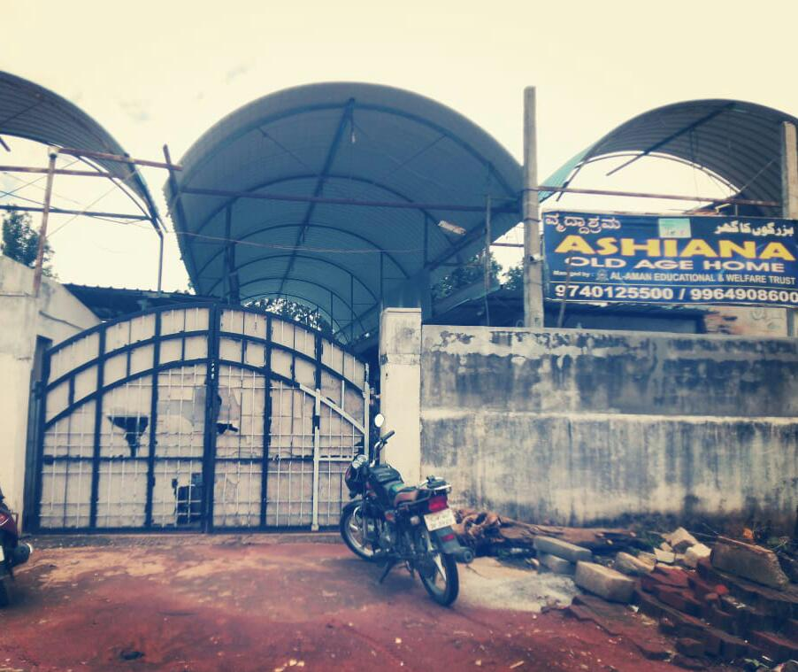 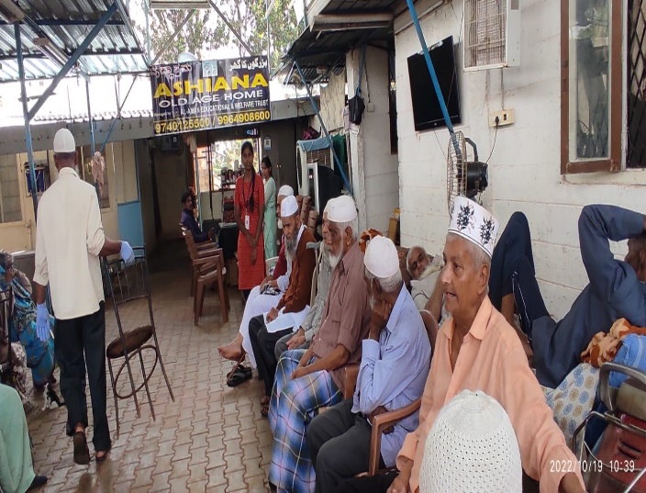

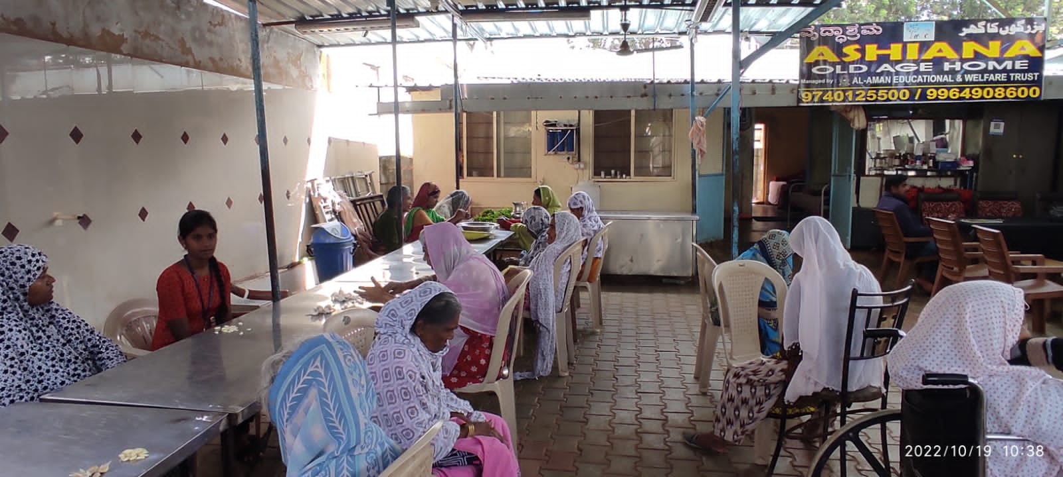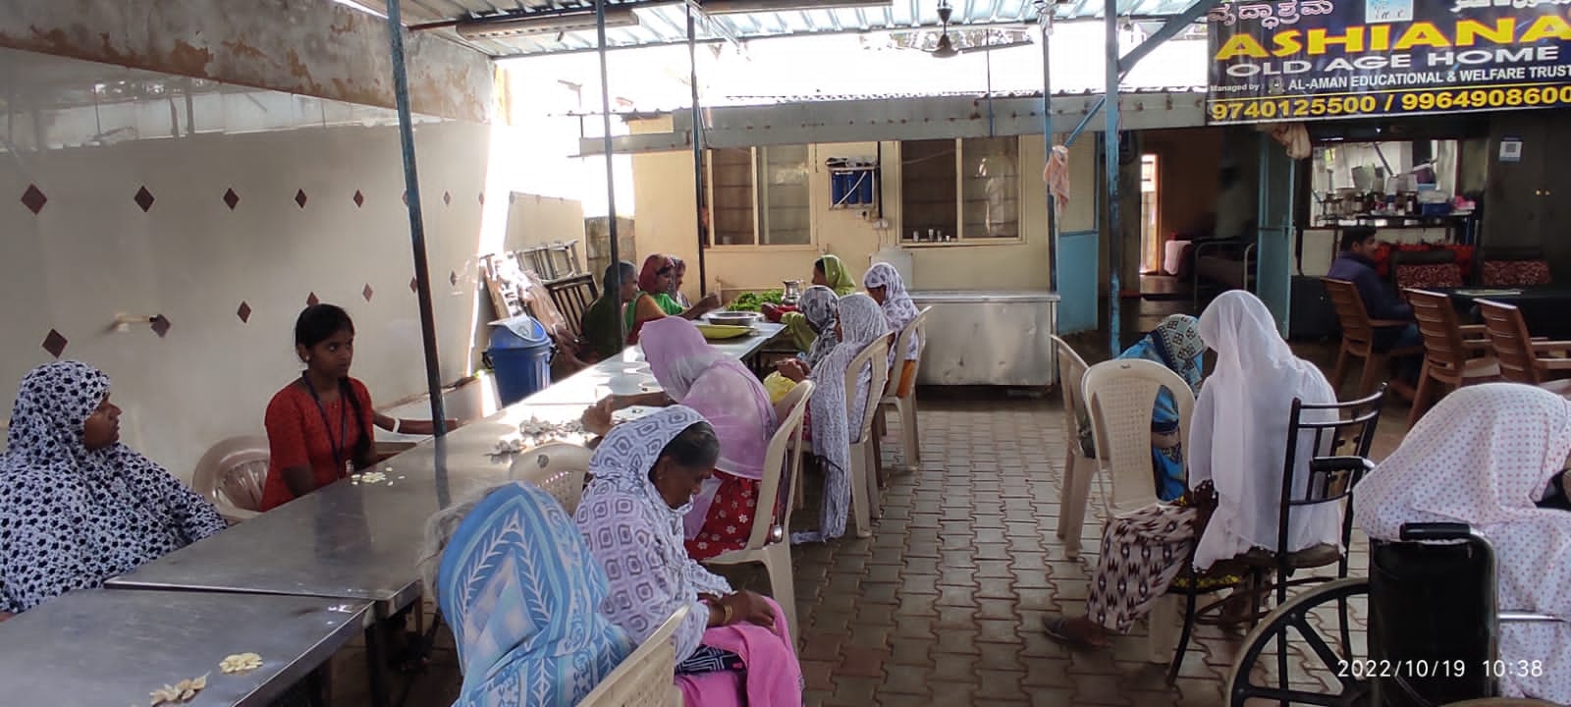 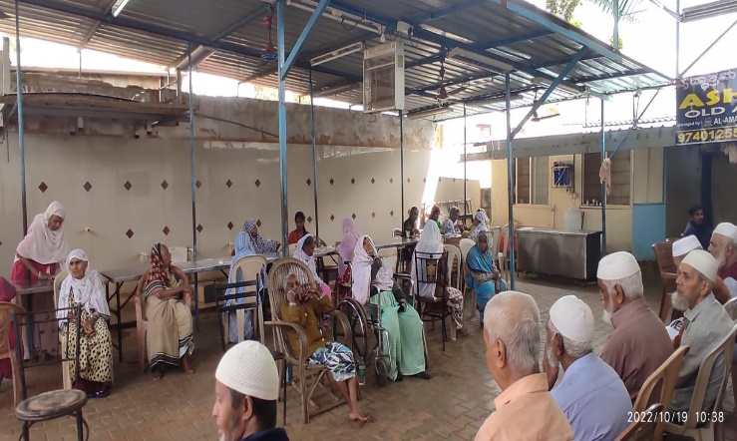 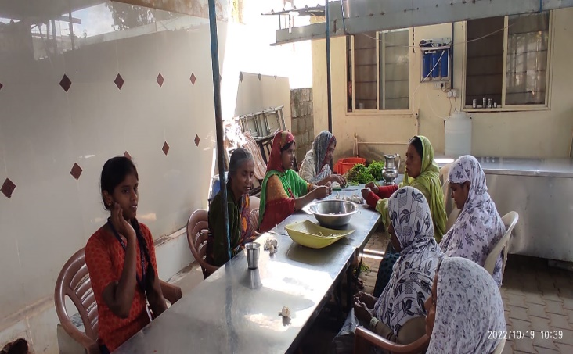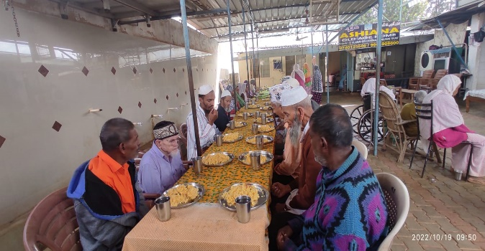 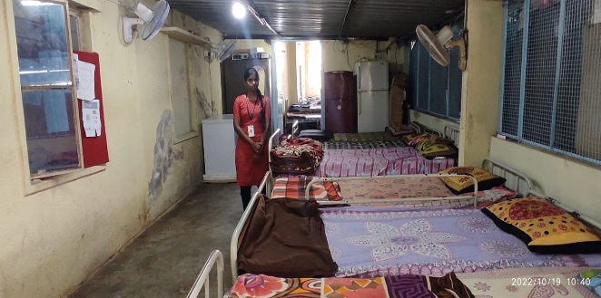

**CONCLUSION**

From this project I have acquired and enhanced many of my skills and experiences. These kids have thought me how to smile in my kind of situation we are in and face it, how to mingle with others, always being positive, hardworking and most important of all helping each other and keeping each other happy. Children were such a cute, lovely and adorable. These kids and staff members made us feel like as if we are their own relation. My communication skill has increased and made new friends.

This internship was a useful experience. I gained new knowledge, skills and met many new people. I achieved several of my learning goals; there is still a lot to discover and to improve. The internship was also good to find out what my strength and weakness are. This helped me to define what skills and knowledge I have to improve in coming time. I would also be better if I can present and express myself more confidently. At the last this internship has given me new insights and motivation.

I didn’t do this because I had it for internship but I did it as my responsibility towards my community. My dream is to start a ashram for old age people and children and make their life more comfortable and happy. I will do it.

**BIBILOGRAPHY**

Ashiana old Age home Trust https://www.ashianahousing.com

**2022**

## **DECLARATION BY STUDENT**

I do hereby declare that the Internship report entitled **COMMUNITY SERVICE PROJECT AT ‘ASHIANA OLD AGE HOME TRUST’** is the outcome of the original work carried out by me under the guidance of “**DIVYA SHREE.B.R”** Assistant Professor, Department of Commerce and Management, Nagarjuna Degree College, Bengaluru – 64, in partial fulfilment for the award of degree of Bachelor of Commerce by Bengaluru City University.

I also declare that this Internship report is the result of my own efforts and it has not been submitted to any other university or Institute for the award of any other degree or Diploma or certificate.

Place: Bengaluru Anusha. R

Date: Student ID:20027619

## **NAGARJUNA DEGREE COLLEGE**

(Affiliated to Bengaluru City University)

**# 38/36, Ramagondanahalli, Yelahanka, Bengaluru -560 064.**

**Phone: 6364231112**

**E Mail:** [**nccms2013@gmail.com**](mailto:nccms2013@gmail.com) **Website:** [**www.nagarjunadegreecollege.co.in**](http://www.nagarjunadegreecollege.co.in/)

## **HOD CERTIFICATE**

This is to certify that the Internship report **COMMUNITY SERVICE PROJECT AT “ASHIANA OLD AGE HOME TRUST”** is the original work conducted by Ms. ANUSHA.R under the guidance of DIVYA SHREE.B.R Assistant Professor, Department of Commerce and Management. This report has not formed a basis for the award of any other Degree or Diploma of any University or Institution.

Place: Bengaluru-64.

Date: Head of the Department

## **NAGARJUNA DEGREE COLLEGE**

(Affiliated to Bengaluru City University)

**# 38/36, Ramagondanahalli, Yelahanka, Bengaluru -560 064.**

**Phone: 6364231112**

**E Mail:** [**nccms2013@gmail.com**](mailto:nccms2013@gmail.com) **Website:** [**www.nagarjunadegreecollege.co.in**](http://www.nagarjunadegreecollege.co.in/)

# GUIDE CERTIFICATE

This is to certify that Ms.ANUSHA.R with student ID No. 20027619 has prepared the Internship Project Report entitled “**COMMUNITY SERVICE PROJECT AT “ASHIANA OLD AGE HOME TRUST”** i under my guidance. This report has not formed a basis for awarding any other Degree or Diploma or Certificate by this University or any other university or Institution.

Place: Bengaluru-64.

Date: Signature of the Guide

## **NAGARJUNA DEGREE COLLEGE**

(Affiliated to Bengaluru City University)

**# 38/36, Ramagondanahalli, Yelahanka, Bengaluru -560 064.**

**Phone: 6364231112**

**E Mail:** [**nccms2013@gmail.com**](mailto:nccms2013@gmail.com) **Website:** [**www.nagarjunadegreecollege.co.in**](http://www.nagarjunadegreecollege.co.in/)

# CERTIFICATE

Certified that Mr. XXXXX bearing Student ID No.20027619 is a student of Third Semester B.Com of Nagarjuna Degree College, Bengaluru-64, has submitted an Internship Project Report entitled “**COMMUNITY SERVICE PROJECT AT “ASHIANA OLD AGE HOME TRUST”** i” prepared in partial fulfilment of the requirements for the award of the Degree of Bachelor of Commerce of Bengaluru City University.

This report has not formed a basis for the award of any other Degree or Diploma or Certificate of any other University or Institute.

Place: Bengaluru-64.

Date: Principal